6. HEAT EXCHANGER
HEAT EXCHANGER: Tt is a device which is used to exchange thermal energy from one fluid to another fluid either direct or indirect contact. E.g. Boiler, Condenser, Evaporator, Etc…
AREA DENSITY ($β$):  $$β=\frac{Surface Area of Heat Exchanger}{Volume of Heat Exchanger}=\frac{A_{s}}{V}$$ | For Car Radiator, $β≈1000$  For Ceramic Glass Turbine, $β≈6000$  For Generator of Stirling engine, $β≈15000$
If $β>700 {m^{2}}/{m^{3}}$, HE is called Compact Type HE.
PARALLEL FLOW: Both the Fluids moving in same direction.
COUNTER FLOW: Both the Fluids moving in opposite direction.
OVERALL HEAT TRANSFER COEFFICIENT (OHTC) ($U in W/{m^{2}K}$):
It’s Experimentally determined Quantity.
$$Q=\frac{∆T}{R_{Total}}=UA∆T \left(\begin{matrix}Extension of Newton^{'}s \\ Law of Cooling\end{matrix}\right)$$ | $$Q=\frac{∆T}{R_{Total}}={\left(UA\right)}_{i}∆T={\left(UA\right)}_{o}∆T$$
Fouling Resistance ($R_{F} in K/W$) $=R_{Old Surface}-R_{New Surface}$ | $$R_{F}=1/{{\left(UA\right)}_{Old}}-1/{{\left(UA\right)}_{New}}$$
Fouling Factor $(in {m^{2}K}/W)=1/{U_{Old}}-1/{U_{New}}$ | If $A_{i}≈A_{o}, R_{cond}≈0 \&U_{o}=U_{i}$
Here, Q remains the along the direction of heat transfer.
HOLLOW CYLINDER | HOLLOW SPHERE | PLANE WALL
$$U_{i}r_{i}=U_{o}r_{o}$$ | $$U_{i}r_{i}^{2}=U_{o}r_{o}^{2}$$ | $$U_{i}=U_{o} Because A_{i}=A_{o}$$
GENERALISED RATE OF THERMAL ENERGY BALANCE:
From SFEE, $Q(in J/{kg})=h_{2}-h_{1}$  $$Q\left(in J/s\right)=\dot{m}\left(h_{2}-h_{1}\right)=\dot{m}C_{P}\left(T_{2}-T_{1}\right)$$  For Both the Fluid of HE, $Q=Q_{loss}=Q_{gain}$  $$Q=-{\dot{m}}_{h}C_{h}\left(T_{h2}-T_{h1}\right)={\dot{m}}_{c}C_{c}\left(T_{c2}-T_{c1}\right)={UA\left(∆T\right)}_{Avg}$$ | ${\dot{m}}_{h},{\dot{m}}_{c}=$ Mass Flow rate of hot fluid and cold fluid (${kg}/s$)  $C_{h},C_{c}=$ Specific heat of hot fluid and cold fluid ($J/{kg K}$)  $T_{h1},T_{h2}=$ Inlet and outlet temperature of hot fluid,  $T_{c1},T_{c2}=$ Inlet and outlet temperature of cold fluid
HEAT CAPACITY RATE ($C$):$C (in W/K)=\dot{m}C_{P}$
- It denotes at given time how much energy required to change a temperature by $1K$ or $1°C$.
- Fluid undergoes large temperature variation at a given time for a fluid having minimum heat capacity rate.
$$C_{min}=\min\left\{{\dot{m}}_{h}C_{h},{\dot{m}}_{c}C_{c}\right\}$$ | $$C_{max}=\max\left\{{\dot{m}}_{h}C_{h},{\dot{m}}_{c}C_{c}\right\}$$
HEAT CAPACITY RATIO ($R$):$R={C_{min}}/{C_{max}}$
- If $R=1$, Temperature change in hot fluid and cold fluid will be same.
- In Phase change (Boiling, Evaporation, Condensation), $C_{max}=∞⇒R=0$
ANALYSIS OF HEAT EXCHANGER:
- LMTD METHOD:
Assumptions:

- 1D Heat Flow (Radial Flow)
- Steady State
- No internal heat generation
- Neglect KE & PE changes
- All thermophysical properties of fluid are constant.
- Overall heat transfer coefficient value is constant.
- Outer surface of heat exchanger is well insulated.
- Radiation heat loss is neglected.
- No Partial phase changes.

CASE-I: DOUBLE PIPE PARALLEL FLOW HEAT EXCHANGER
$$dQ=-{\dot{m}}_{h}C_{h}dT_{h}={\dot{m}}_{c}C_{c}dT_{c}={UdA\left(∆T\right)}_{Avg}$$ | $$Q=-{\dot{m}}_{h}C_{h}\left(T_{h2}-T_{h1}\right)={\dot{m}}_{c}C_{c}\left(T_{c2}-T_{c1}\right)=UA\left(LMTD\right)$$
$$d\left(T_{h}-T_{c}\right)=-dQ μ_{P}$$ $$d\left(∆T\right)=-dQ μ_{P}⋯(1)$$ $$μ_{P}=\frac{1}{{\dot{m}}_{h}C_{h}}+\frac{1}{{\dot{m}}_{c}C_{c}}$$  By integration,$μ_{P}={\left(∆T_{1}-∆T_{2}\right)}/Q⋯(2)$ |  | $$dQ={UdA\left(∆T\right)}_{Avg}$$  By integration & Eq. (1),  $$\ln\left({∆T_{1}}/{∆T_{2}}\right)=UAμ_{P}⋯(3)$$
From Equation (2) & (3),  $${\left(∆T\right)}_{Avg}=LMTD$$ |  | $$LMTD=\frac{∆T_{1}-∆T_{2}}{\ln\left({∆T_{1}}/{∆T_{2}}\right)}\left(\begin{matrix}Always Same in \\ °C or K \&>1\end{matrix} \right)$$
CASE-II: DOUBLE PIPE COUNTER FLOW HEAT EXCHANGER
$$dQ=-{\dot{m}}_{h}C_{h}dT_{h}=-{\dot{m}}_{c}C_{c}dT_{c}={UdA\left(∆T\right)}_{Avg}$$ | $$Q=-{\dot{m}}_{h}C_{h}\left(T_{h2}-T_{h1}\right)=-{\dot{m}}_{c}C_{c}\left(T_{c2}-T_{c1}\right)=UA\left(LMTD\right)$$
$$d\left(T_{h}-T_{c}\right)=-dQ μ_{C}$$ $$d\left(∆T\right)=-dQ μ_{C}⋯(1)$$ $$μ_{C}=\frac{1}{{\dot{m}}_{h}C_{h}}-\frac{1}{{\dot{m}}_{c}C_{c}}$$  By integration,$μ_{C}={\left(∆T_{1}-∆T_{2}\right)}/Q⋯(2)$ |  | $$dQ={UdA\left(∆T\right)}_{Avg}$$  By integration & Eq. (1),  $$\ln\left({∆T_{1}}/{∆T_{2}}\right)=UAμ_{C}⋯(3)$$
From Equation (2) & (3),  $${\left(∆T\right)}_{Avg}=LMTD$$ |  | $$LMTD=\frac{∆T_{1}-∆T_{2}}{\ln\left({∆T_{1}}/{∆T_{2}}\right)}\left(\begin{matrix}Always Same in \\ °C or K \&>1\end{matrix} \right)$$

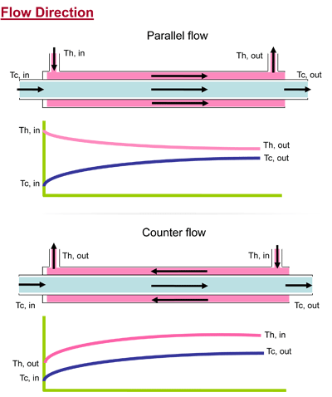 |  |  | 
$$∆T_{1}=T_{h1}-T_{c1}$$ | $$∆T_{2}=T_{h2}-T_{c2}$$ | $$∆T_{1}=T_{h1}-T_{c2}$$ |  | $$∆T_{2}=T_{h2}-T_{c1}$$

LMTD | AMTD | By series expansion of ln term in LMTD,  $$LMTD=\frac{AMTD}{1+\frac{1}{3}{\left[\frac{∆T_{1}-∆T_{2}}{∆T_{1}+∆T_{2}}\right]}^{2}}$$
$$LMTD=\frac{∆T_{1}-∆T_{2}}{\ln\left({∆T_{1}}/{∆T_{2}}\right)}$$ | $$AMTD=\frac{∆T_{1}+∆T_{2}}{2}$$
If $∆T_{1}=∆T_{2}, LMTD=AMTD$(Linear Profile), Else $LMTD<AMTD$
SPECIAL CASES:
CASE-I: When Both fluids have equal heat capacity rate in counter flow heat exchanger. $C_{min}=C_{max}$
$$R=1$$  $$d\left(∆T\right)=0$$ | $$\frac{dT_{h}}{dx}=-\frac{UP{\left(∆T\right)}_{Avg}}{{\dot{m}}_{h}C_{h}}=Const.$$ | $$\frac{dT_{c}}{dx}=-\frac{UP{\left(∆T\right)}_{Avg}}{{\dot{m}}_{c}C_{c}}=Const.$$ | $$LMTD=∆T_{1}=∆T_{2}=AMTD (Linear Profile)$$
In counter flow when $R=1$, temperature profile is linear & parallel.
CASE-II: Phase Change Devices ($C_{max}=∞⇒R=0$)
Boiler/ Evaporator:
$∆T_{1}, ∆T_{2}, LMTD$ For Parallel Flow and Counter Flow are same for Boiling & evaporation process.  For Evaporator,  $$Q=-{\dot{m}}_{h}C_{h}\left(T_{h2}-T_{h1}\right)={\dot{m}}_{c}h_{fg}=UA\left(LMTD\right)$$  For Condenser,  $$Q={\dot{m}}_{h}h_{fg}={\dot{m}}_{c}C_{c}\left(T_{c2}-T_{c1}\right)=UA\left(LMTD\right)$$  $${\left(∆T_{1}\right)}_{P}={\left(∆T_{2}\right)}_{C}$$ $${\left(∆T_{2}\right)}_{P}={\left(∆T_{1}\right)}_{C}$$  $${\left(LMTD\right)}_{P}={\left(LMTD\right)}_{C}$$ | 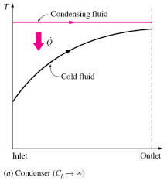 | 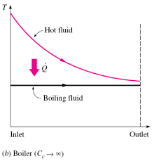
COMPARISON OF PARALLEL FLOW & COUNTER FLOW:
In parallel Flow, $T_{h2}$ cannot be less than $T_{c2}$. | In Counter Flow, $T_{h2}$ can be less than $T_{c2}$.
So, Possibility in Counter Flow,
$$C_{min}={\dot{m}}_{h}C_{h}$$ | $$C_{min}={\dot{m}}_{c}C_{c}$$ | $$Q_{max}=C_{min}{\left(∆T\right)}_{max}$$  Where, ${\left(∆T\right)}_{max}=T_{h1}-T_{c1}$
It may possible that, $T_{h2}=T_{c1}$ | It may possible that, $T_{h1}=T_{c2}$
$$Q_{max}=C_{min}\left(T_{h1}-T_{c1}\right)$$ | $$Q_{max}=C_{min}\left(T_{h1}-T_{c1}\right)$$
- $Q_{max}$ is calculated for a fluid having minimum heat capacity rate by assuming counter flow HE of infinite length.
- When $Q \& U$ is constant,
$${LMTD}_{Counter}>{LMTD}_{Cross}>{LMTD}_{Parallel}$$ | $$A_{Counter}<A_{Cross}<A_{Parallel}$$ | $$A_{s}LMTD=Constant$$
- In HE, Counter Flow HE is considered as reference.
- $Q_{Cross or Multipass}=UA{\left(LMTD\right)}_{Cross or Multipass}$
$${LMTD}_{Cross or Multipass}={LMTD}_{Counter}*F, Where F=Correction Factor≤1$$
$F$ Depends on Geometry & Flow Direction.
- For counter flow or Phase change devices $F=1$
NOTE: Parallel Flow HE is used when Oil because with increasing temperature Viscosity decreases and pump power decreases. Hence, Selection is purely depending on the Requirement.
LMTD Method is used to find surface area of HE when outlet Temp. of fluid is known ($T_{h2} or T_{c2} must be known$).

- EFFECTIVENESS ($ϵ$) NTU METHOD:
$$ϵ=\frac{Actual Heat Loss From Any One Fluid}{Maximum Heat Loss From Fluid}=\frac{Q_{Act}}{Q_{Max}}≤1$$
HOT FLUID WITH$C_{min}$ | COLD FLUID WITH $C_{min}$
$$ϵ=\frac{Q_{Act}}{Q_{Max}}=\frac{{\dot{m}}_{h}C_{h}\left(T_{h1}-T_{h2}\right)}{C_{min}\left(T_{h1}-T_{c1}\right)}=\frac{T_{h1}-T_{h2}}{T_{h1}-T_{c1}}⋯\left(1\right)$$ | $$ϵ=\frac{Q_{Act}}{Q_{Max}}=\frac{{\dot{m}}_{c}C_{c}\left(T_{c2}-T_{c1}\right)}{C_{min}\left(T_{h1}-T_{c1}\right)}=\frac{T_{c2}-T_{c1}}{T_{h1}-T_{c1}}⋯\left(1\right)$$
$${\dot{m}}_{h}C_{h}\left(T_{h1}-T_{h2}\right)={\dot{m}}_{c}C_{c}\left(T_{c2}-T_{c1}\right)=UA\left(LMTD\right)$$  $$R=\frac{C_{min}}{C_{max}}=\frac{T_{c2}-T_{c1}}{T_{h1}-T_{h2}}=\frac{Smaller Temp. Drop}{Larger Temp. Drop}⋯\left(2\right)$$  $$NTU=\frac{UA}{C_{min}}=\frac{T_{h1}-T_{h2}}{LMTD}=\frac{Large Temp. Diff.}{Avg. Temp. Diff.}⋯\left(4\right)$$ | $${\dot{m}}_{h}C_{h}\left(T_{h1}-T_{h2}\right)={\dot{m}}_{c}C_{c}\left(T_{c2}-T_{c1}\right)=UA\left(LMTD\right)$$  $$R=\frac{C_{min}}{C_{max}}=\frac{T_{h1}-T_{h2}}{T_{c2}-T_{c1}}=\frac{Smaller Temp. Drop}{Larger Temp. Drop}⋯\left(2\right)$$  $$NTU=\frac{UA}{C_{min}}=\frac{T_{c2}-T_{c1}}{LMTD}=\frac{Large Temp. Diff.}{Avg. Temp. Diff.}⋯\left(4\right)$$
From $\left(1\right)$ & $\left(2\right)$  $$ϵR=\frac{T_{c2}-T_{c1}}{T_{h1}-T_{c1}}⋯\left(3\right)$$ | From $\left(1\right)$ & $\left(2\right)$  $$ϵR=\frac{T_{h1}-T_{h2}}{T_{h1}-T_{c1}}⋯\left(3\right)$$

EFFECTIVENESS OF PARALLEL FLOW | EFFECTIVENESS OF COUNTER FLOW
HOT FLUID WITH$C_{min}$ | HOT FLUID WITH$C_{min}$
$$μ_{P}=\frac{1}{{\dot{m}}_{h}C_{h}}+\frac{1}{{\dot{m}}_{c}C_{c}}=\frac{1}{C_{min}}\left[1+R\right]$$ | $$μ_{C}=\frac{1}{{\dot{m}}_{h}C_{h}}-\frac{1}{{\dot{m}}_{c}C_{c}}=\frac{1}{C_{min}}\left[1-R\right]$$
$$\ln\left(\frac{∆T_{1}}{∆T_{2}}\right)=UAμ_{P}⇒1-\frac{∆T_{2}}{∆T_{1}}=K=1-e^{-UAμ_{P}}$$  $$∴1-\frac{∆T_{2}}{∆T_{1}}=ϵ\left[1+R\right]=K⇒ϵ=\frac{K}{1+R}$$  $$∴ ϵ=\frac{1-e^{-UAμ_{P}}}{1+R}=\frac{1-e^{-NTU\left[1+R\right]}}{1+R}=f(NTU,R)$$ | $$\ln\left(\frac{∆T_{1}}{∆T_{2}}\right)=UAμ_{C}⇒\frac{∆T_{2}}{∆T_{1}}=K=e^{-UAμ_{C}}$$  $$∴\frac{∆T_{2}}{∆T_{1}}=\frac{1-ϵ}{1-Rϵ}=K⇒ϵ=\frac{1-K}{1-RK}=\frac{1-e^{-UAμ_{C}}}{1-Re^{-UAμ_{C}}}$$  $$∴ ϵ=\frac{1-e^{-NTU\left[1-R\right]}}{1-R e^{-NTU\left[1-R\right]}}=f(NTU,R)$$
CASE-I: For Boiling or Condensation (Phase Change),  $$ϵ=1-e^{-NTU}\left(∵R=0\right)$$  For $NTU→∞$, $ϵ_{max}=1$  CASE-II: Both the fluids have equal heat capacity rate,  $$ϵ={\left(1-e^{-2NTU}\right)}/2\left(∵R=1\right)$$  For $NTU→∞$, $ϵ_{max}=0.5$  CASE-III: For $NTU→∞$, $ϵ_{max}=1/{\left(1+R\right)}$  NOTE: For more effectiveness $NTU→∞ \& R→0$ | CASE-I: For Boiling or Condensation (Phase Change),  $$ϵ=1-e^{-NTU}\left(∵R=0\right)$$  For $NTU→∞$, $ϵ_{max}=1$  CASE-II: Both the fluids have equal heat capacity rate,  $$ϵ={NTU}/{\left(1+NTU\right)}\left(∵R=1, L^{'}hospital\right)$$  For $NTU→∞$, $ϵ_{max}=1$
Parallel Flow: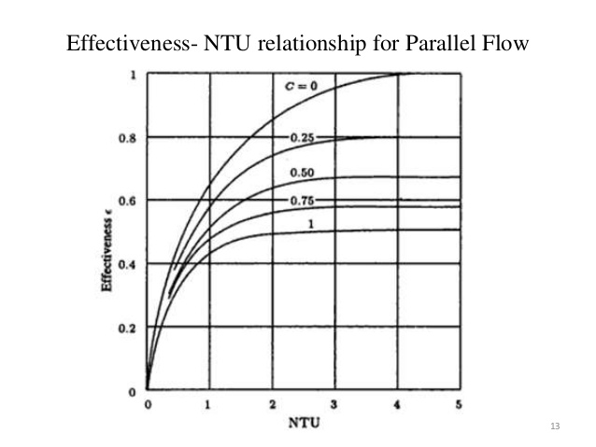Counter Flow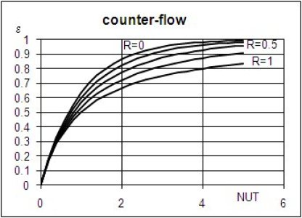 | NTU Method Important Points:  Here, $Q_{Act}=ϵ C_{min}\left(T_{h1}-T_{c1}\right)$  $$ϵ=f\left(NTU,R\right)$$  $$But for NTU<0.3,ϵ≈Const.≠f\left(R\right)$$  $$NTU=\frac{UA}{C_{min}}$$ $$R=\frac{C_{min}}{C_{max}}$$  $$Q_{Act}={\dot{m}}_{c}C_{c}\left(T_{c2}-T_{c1}\right)={\dot{m}}_{h}C_{h}\left(T_{h1}-T_{h2}\right)$$  $$NTU∝Area∝ ϵ∝Q_{Act}$$  NTU Measures Size of HE & It’s also called as dimensionless area. For Good Thermal & Economical Design NTU is limited up to 1.5. NTU increase rapidly from 0 to 1.5. Beyond 3 NTU is almost Constant.  $$ϵ_{Counter}>ϵ_{Cross}>ϵ_{Parallel}$$  For phase Change, $ϵ_{Counter}=ϵ_{Cross}=ϵ_{Parallel}$  As NTU increases the Size of HE increases (Bulky).  $NTU$= No. of Heat Transfer Unit  $NTU$ is representation of $St$ Stanton Number in terms of $U$ (Overall heat Transfer Coefficient.)
Same results can be obtained for cold fluid with $C_{min}$

LMTD Method | NTU Method
It’s used when Temperature is given and Area required to find for the Heat Exchanger. | It’s used when Area is given and Temperature required to find for the Heat Exchanger.

